MASS MEDIA RELEASE
Riga, 27 April 2021
The Latvian National Museum of Art is inviting to the  International Scientific Conference  Symbolism in Europe and the Identity of the Baltic Nations | 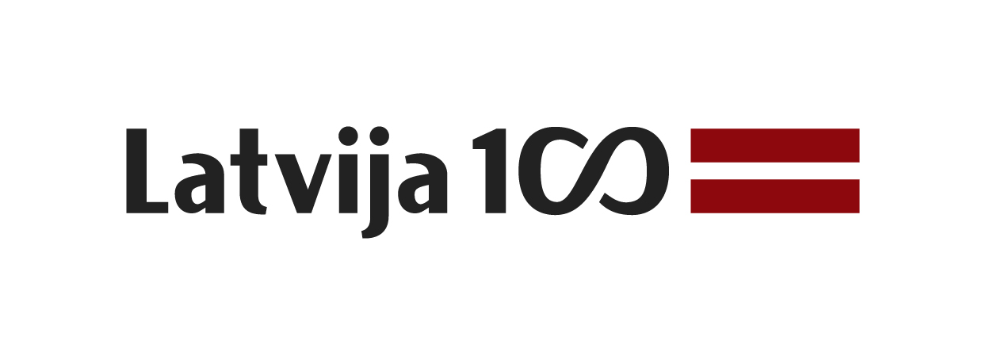

29 April 2021
10.00–19.00
The main building of the Latvian National Museum of Art / broadcast live on the LNMA’s Facebook page
Jaņa Rozentāla laukums 1, Riga, LV-1010, Latvia

With the Latvian Centenary exhibition Wild Souls. Symbolism in the Art of the Baltic States drawing to a close, on Thursday, 29 April 2021, the Latvian National Museum of Art in Riga will host an international scientific online conference, Symbolism in Europe and the Identity of the Baltic Nations. Among the participants will be experts in the field from Latvia, Lithuania, France, and Sweden who were involved in the making of the exhibition and its catalogue and have realised other international projects on the subject. The broadcast starts at 10.00.

Today, in retrospect, we can see that the programme of Latvia’s Centenary, organised by the Ministry of Culture, was an opportunity to realise ambitious ideas, showcase the most significant turning points in the history of our country and bring major international projects to fruition. From 10 April to 15 July 2018, Musée d’Orsay in Paris hosted the exhibition Wild Souls. Symbolism in the Baltic States (Âmes sauvages. Le symbolisme dans les pays baltes) – a co-project on the centenary of the three Baltic States and one of the main representational events of Latvia abroad. The exhibition invited French viewers and many thousands of tourists from across the world to get to know Symbolism in Lithuanian, Estonian and Latvian art from the 1890s until 1930s. It was an opportunity to talk about the Baltic States, underlining the artistic specificity, historical heritage and traditions of each country.

After the Musée d’Orsay, the exhibition was successfully presented at the Kumu Art Museum in Tallinn (11.10.2018–03.02.2019), traveling to the National Gallery of Art of the Lithuanian National Museum of Art in Vilnius (25.07–11.10.2020) and concluding the route at the Latvian National Museum of Art in Riga (LNMA, 21.11.2020–04.05.2021). Each of the museums in our neighbouring countries offered their perspective and contributions of scientific capacity.

Concluding the exhibition Wild Souls. Symbolism in the Art of the Baltic States, the Latvian National Museum of Art in collaboration with the Art Academy of Latvia (AAL) presents an international scientific conference, Symbolism in Europe and the Identity of the Baltic Nations. The conference is envisioned as the final stage for the exchange of scientific ideas and research related to Baltic Symbolism in the broadest sense as well as the project’s overall realisation.

Main topics to be discussed during the conference:
1) Symbolism in Europe and its boundaries, including research about Baltic art;
2) phenomenon of Art Nouveau architecture in Riga as part of Baltic and European architectural heritage;
3) key figures during the Symbolist period (in art, literature, music) in the general context of Baltic culture;
4) expression of separate and shared identities of the Baltic nations in history, culture and art in the context of the study of Symbolism;
5) importance of cultural centres in the Baltic States in the late 19th – early 20th century, their influence on formation and development of national art;
6) Symbolist works in museum collections.

Aim and participants of the conference:
The conference is planned as an international event bringing together researchers who have dealt with the subject of Symbolism on a European scale as well as across disciplines, providing a wider context (music, literature, cultural expressions, social perspective etc.) to the art-historical discourse.

Different aspects within the national art schools will be highlighted by guest speakers – Daniel Prytz, Nationalmuseum in Stockholm (Sweden), Algė Andriulytė, Vilnius Academy of Arts, Vaiva Laukaitienė, M. K. Čiurlionis National Museum of Art in Kaunas (Lithuania), and Yves Plasseraud with Suzanne Pourchier-Plasseraud, pioneers and long-term researchers of history of the Baltic region in France. Latvia will be represented at the conference by professors from the Art Academy of Latvia – Eduards Kļaviņš and Silvija Grosa, as well as the senior researcher at the AAL’s Institute of Art History Kristiāna Ābele, while the Latvian National Museum of Art – by curators and researchers Dace Lamberga, Aija Brasliņa, Edvarda Šmite, and Ginta Gerharde-Upeniece.

“As we bring the presentation of the project of Baltic Symbolism to a conclusion back here in Riga, we may consider that this, too, is a privileged opportunity, because our united team has succeeded in drawing attention to the Baltic States not only at the cultural but also at the political and diplomatic level, attracting the interest of visitors to the exhibition in Paris, Tallinn, Vilnius and Riga. We have helped France and Europe discover the Baltic, at the same time demonstrating to ourselves a capacity for jointly realising such ambitious ideas. Laurence des Cars, President of the Musée d’Orsay, has emphasised repeatedly that Europe is united not only politically but also in the creation of common cultural values. Because of this conviction it was possible to demonstrate that, alongside the work of well-known masters, the contribution of artists from the little-known Baltic forms part of Europe’s common cultural heritage,” says the project manager Dr.art. Ginta Gerharde-Upeniece, Head of the Latvian Visual Arts Department, LNMA.

Conference’s target audience: art historians, researchers in various fields of cultural history and theory, museum professionals, representatives of cultural institutions, general public.

Conference’s working languages: Latvian and English.

You are warmly welcome!

The conference will be broadcast live throughout the day on the LNMA’s Facebook page.
After the conference, recording of the live broadcast will be accessible on the LNMA’s Facebook page and Youtube channel.

CONFERENCE PROGRAMME:
10.00–10.30 Conference opening
* Māra Lāce, Director of Latvian National Museum of Art
* Egils Levits, President of Latvia
* Aurélie Royet-Gounin, Ambassador of France to the Republic of Latvia
* Nauris Puntulis, Minister of Culture of the Republic of Latvia
10.30–12.00 Session I, moderated by Dr.art. Ginta Gerharde-Upeniece
* Questions about Specifics and the Borderline of Latvian Symbolism
Prof. emeritus, Dr.hab.art. Eduards Kļaviņš,
Institute of Art History of the Art Academy of Latvia / Riga, Latvia
* Symbols of Social Reforms and the Modern Era
in the Décor of Late Art Nouveau Architecture in Riga
Prof., Dr.art. Silvija Grosa, Art Academy of Latvia / Riga, Latvia
* The Skyline of Art Life in Riga:
A Retrospective and Prospective View from the Scaffolding of 1910
Dr.art. Kristiāna Ābele,
Institute of Art History of the Art Academy of Latvia / Riga, Latvia
Discussion
12.00–12.15 Break
12.15–14.15 Session II, moderated by Dr.art. Silvija Grosa
* To Broaden and Define the Scope of Swedish Symbolist Art:
Its Representation in Exhibitions at the Turn of the 20th Century and Today
Mg.art. Daniel Prytz, Nationalmuseum / Stockholm, Sweden
* Symbolic Motifs in Ferdynand Ruszczyc’s Graphic Design
Dr.art. Algė Andriulytė, Lithuanian National Museum of Art,
Institute of Art Research of Vilnius Academy of Arts / Vilnius, Lithuania
* Religious Motifs in M. K. Čiurlionis’s Art
Mg.art. Vaiva Laukaitienė,
M. K. Čiurlionis National Museum of Art / Kaunas, Lithuania
* Black Serpent Grinding Flour: Janis Rozentāls, Caught between National and European Trends in Latvian Symbolism at the Turn of the 20th Century
Dr.art. Aija Brasliņa, Latvian National Museum of Art / Riga, Latvia
Discussion
14.15–15.00 Break
15.00–17.00 Session III, moderated by Dr.art. Aija Brasliņa
* Janis Rozentāls (1866–1916). After the Cockcrow.
Dedication to the 130th Anniversary of the Artists’ Group Rūķis (19(31).01.1891) and Commemoration of Janis Rozentāls in 2021
Dr.h.c.art. Edvarda Šmite, Latvian National Museum of Art / Riga, Latvia
* Post-Symbolism and the Creative Search of the New Generation of Artists
Dr.art. Dace Lamberga, Latvian National Museum of Art / Riga, Latvia
* Latvia and Latvians as Seen from France
Dr.iur. Yves Plasseraud, expert in Baltic region history / Paris, France
* Latvian Exhibitions in France: Diplomatic Media
Dr.hist. Suzanne Pourchier-Plasseraud, independent researcher / Paris, France
* What is So Wild Here? Synergy and Resonance of the Project
Symbolism in the Art of the Baltic States
Dr.art. Ginta Gerharde-Upeniece, Latvian National Museum of Art / Riga, Latvia
Discussion
Conclusion of the Conference
17.00–18.00 Symbolism of Images in Ancient Estonian Folk Songs and
in the Epic Kalevipoeg
Gundars Godiņš (18 January 2021, record)
18.00–19.00 Music and Symbolism:
The Moon, the Dream of an Orchid and the Lake of the Moon
Orests Silabriedis (21 January 2021, record)

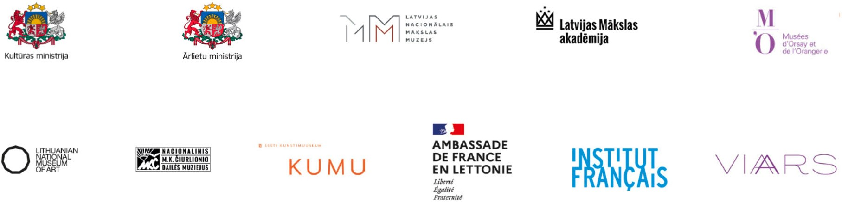

HEAD OF THE PROJECT:
Dr.art. Ginta Gerharde-Upeniece,
Head of the Latvian Visual Arts Department / Latvian National Museum of Art / Riga, Latvia
Ph: (+371) 67 716101, E: Ginta.Gerharde@lnmm.lv

INTERNET SOURCES:
www.lnmm.lv
www.neputns.lv
www.lv100.lv
www.musee-orsay.fr
https://kumu.ekm.ee/en/syndmus/symbolism-in-the-art-of-the-baltic-states
http://www.ndg.lt/exhibitions/present/wild-souls.aspx
http://www.institut-francais.lv
FACEBOOK: Latvijas Nacionālais mākslas muzejs; Latvija100
YOUTUBE: Latvian National Museum of Art / LNMMvideos;
LV100; https://www.youtube.com/watch?time_continue=8&v=pIBtd3yqCcs
TWITTER: @LNMM_muzejs; @LatvijaiSimts
INSTAGRAM: @latviannationalmuseumofart
FLICKR: Latvia100
#lnmm
#LV100
#MansMuzejs

PRESS IMAGES (please request if needed in a larger resolution)
1. Rūdolfs Pērle (1875–1917). The Sun. 1916. Tempera on canvas.
Collection of the Latvian National Museum of Art, Riga. Photo: Normunds Brasliņš
2. Johans Valters (1869–1932). Peasant Girl. Ca. 1904. Oil on canvas.
Collection of the Latvian National Museum of Art, Riga. Photo: Normunds Brasliņš
3. Johans Valters (1869–1932). Landscape with a River. 1904. Oil on canvas.
Collection of the Latvian National Museum of Art, Riga. Photo: Normunds Brasliņš
4. Janis Rozentāls (1866–1916). Arcadia. Ca. 1910. Oil on canvas.
Collection of the Latvian National Museum of Art, Riga. Photo: Normunds Brasliņš
5. Aleksandrs Romans (1878–1911). Landscape with a Horseman. 1910. Oil on canvas.
Collection of the Latvian National Museum of Art, Riga. Photo: Normunds Brasliņš
6. Mikalojus Konstantinas Čiurlionis (1875–1911). Fairy Tale (Kings’ Fairy Tale). 1909. Tempera on canvas.
Collection of the M. K. Čiurlionis National Museum of Art, Kaunas. Photo: Arūnas Baltėnas
7. Ferdynand Ruszczyc (1870–1936). Nec mergitur. 1904–1905. Oil on canvas.
Collection of the Lithuanian National Museum of Art, Vilnius. Publicity photo
8. Oskar Kallis (1892–1918). Kalev on an Eagle. 1917. Oil on canvas.
Collection of the Art Museum of Estonia, Tallinn. Publicity photo
9-12. Exhibition Wild Souls. Symbolism in the Art of the Baltic States at the Latvian National Museum of Art in Riga. 2020/2021. Photo: Otto Strazds

Press release prepared by: Natalie Suyunshalieva
Head of Press
The Latvian National Museum of Art
Ph: (+371) 67 357527
GSM: (+371) 26 593495
E: pr.service@lnmm.lv
I: www.lnmm.lv
Twitter: www.twitter.com/lnmm_muzejs

