MASS MEDIA RELEASE
Riga, 26 July 2023 [last update: 18.08.2023]

Sandro Miller.
Malkovich, Malkovich, Malkovich: Homage to Photographic Masters

26 August – 29 October 2023
Main building of the Latvian National Museum of Art / Cupola Hall (5th floor)
Jaņa Rozentāla laukums 1, Riga

Media tour of exhibition on 25 August 2023 at 12.00
Registration of participants: 11.30–12.00

From 26 August to 29 October 2023, Malkovich, Malkovich, Malkovich: Homage to Photographic Masters, a series of works by the internationally renowned American photographer Sandro Miller is on view in the Cupola Hall of the main building of the Latvian National Museum of Art in Riga (Jaņa Rozentāla laukums 1).

The exhibition is organised by the Latvian National Museum of Art (LNMA) together with the Madrid-based cultural management company diChroma photography. The unique art photography exhibition is the result of a cooperation between two powerful creative personalities – American photographer of Italian descent Sandro Miller (SANDRO) and the celebrated American film and theatre actor John Malkovich. They share a years-long friendship, and Malkovich has been Miller’s model on several occasions.

In the series Malkovich, Malkovich, Malkovich: Homage to Photographic Masters, Sandro Miller paraphrases the images created by most outstanding 20th century classics of photography – portraits of celebrities as well as images of unknown individuals who have become famous owing to the specific photographs. The paraphrases reconstruct the compositions, lighting, poses and clothing of the models from the original, iconic photographs. However, the depicted persons – Irving Penn’s cornered Truman Capote, Bert Stern’s undressed Marilyn Monroe, Dorothea Lange’s classic immigrant mother, Richard Avedon’s man with bees, Robert Mapplethorpe’s self-portraits and many others – are replaced by only… John Malkovich. The artist duo of photographer and actor produce an exciting and critical interplay between the canonicalized images and their repetitions, providing an ironic commentary on the role of certain figures and images in the development of photography.

Sandro Miller (1958) has enjoyed great success in commercial and portrait photography, having collaborated with globally influential brands (American Express, Coca-Cola, BMW) and magazines (Forbes, GQ, Esquire). At the same time, author develops art projects in the fields of photography and cinema. His solo exhibitions have been held on both sides of the Atlantic – from his home in Chicago to museums and exhibition halls in Europe and Asia.

The series of works presented in Riga has earned broad recognition having been exhibited, reproduced and reviewed many times. Now, nine years after its debut at the Catherine Edelman Gallery in Chicago (2014) and stunning presentation at the seminal Les Rencontres d’Arles Photographie (2015), it is being shown in the Latvian National Museum of Art. It should be noted that in 2015 SANDRO project received the prestigious Lucie Foundation award in the International Photographer of the Year category.

LNMA expresses its gratitude to all those involved in the project, especially thanking businessman Dmitry Krupnikov for his contribution to the organization and promotion of the exhibition.

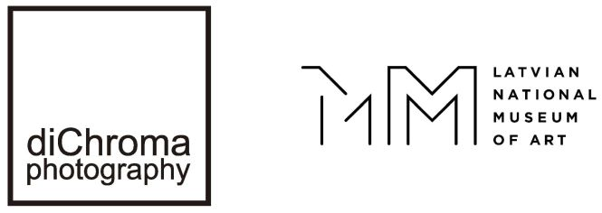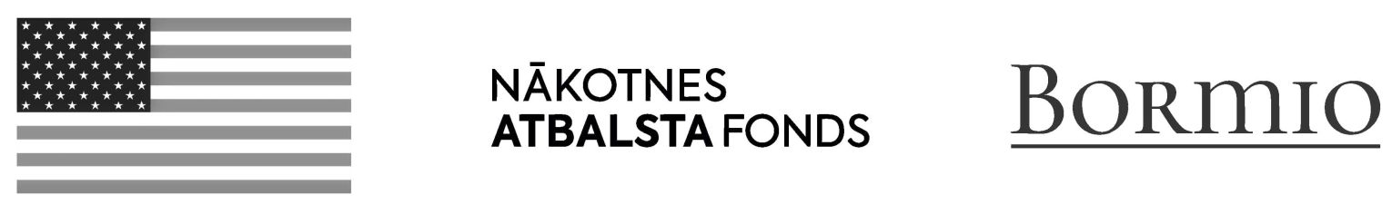

Organizers:
Cultural management company diChroma photography / Madrid, Spain
Latvian National Museum of Art / Riga, Latvia

Supporters:
U.S. Embassy in Latvia, foundation Nākotnes atbalsta fonds, Bormio Ltd. and Dmitry Krupnikov

Project curators:
Anne Morin / diChroma photography, Spain

Inese Baranovska, Head of the Museum of Decorative Arts and Design / Latvian National Museum of Art, Latvia
Ph: (+371) 67 830 900, E: Inese.Baranovska@lnmm.lv

Astrīda Rogule, Curator of the Contemporary Art Collection / Latvian National Museum of Art, Latvia
Ph: (+371) 60 007 718, E: Astrida.Rogule@lnmm.lv

Exhibition design concept and graphic identity:
Artūrs Analts, artist

Technical solutions:
Yes We Can

INTERNET SOURCES:
www.lnmm.lv
www.sandrofilm.com/grid/projects
FACEBOOK: Latvijas Nacionālais mākslas muzejs
TWITTER: @LNMM_muzejs
INSTAGRAM: @makslasmuzejs
YOUTUBE: MĀKSLAS MUZEJI / LNMMvideos
#lnmm
#MansMuzejs

The main building of the Latvian National Museum of Art / Jaņa Rozentāla laukums 1, Riga, Latvia
OPENING HOURS:
Tuesdays, Wednesdays, Thursdays 10.00–18.00, ticket office 10.00–17.30
Fridays 10.00–20.00, ticket office 10.00–19.30
Saturdays, Sundays 10.00–17.00, ticket office 10.00–16.30
Closed on Mondays

The museum is closed on all public holidays: 1 January, Good Friday, Easter, Midsummer Eve and Day (23–24 June), Christmas (25–26 December), 31 December.

ADMISSION: NB! (this ticket allows you to visit the entire museum)
Reduced individual admission fee for groups of 10 or more people.
Free admission for the person in charge of the group.
Adults: 8,00 EUR
Students, seniors: 4,50 EUR
Schoolchildren: 3,50 EUR
Family ticket (1–2 adults with 1–4 children or family having many children): 5,00–7,00 EUR
Free admission for LNMA Annual ticket holders.

Free entry is also for: pre-school children; orphans or children not under parental care (valid status identification card required); children with a disability up to 18 years, 1st and 2nd group disabled persons (valid status identification card required) and one person accompanying either a child with a disability up to 18 years or a 1st or 2nd group disabled person; pupils of Latvian art schools or professional secondary art schools (valid status identification card required); full-time students of the Art Academy of Latvia (valid status identification card required); students attending institutions of professional secondary education or colleges who are studying or receiving training in visual or applied art, design, cultural history, museology, architecture, restoration as part of their studies or training (on submission of a written application to the museum director at least one day earlier); employees of Latvian museums (valid status identification card required); members of the International Council of Museums (ICOM, valid status membership card required); members of the Latvian Artists’ Union (valid status identification card required); Friend of the LNMA card holders; media representatives who are covering museum events (valid status identification card required); group (no less than 10 persons) leaders – guides or teachers; Ukrainian citizens by presenting an identity document or other document proving Ukrainian citizenship; everyone on the international event Museum Night from 19.00; all visitors to the permanent display on the last Sunday of every month and on International Museum Day – 18th May.

HEALTH AND SAFETY MEASURES AT THE MUSEUM:
- Please do not visit the museum, if you have symptoms of a respiratory infection, or if you must be in self-isolation, home quarantine or strict isolation. The museum has the right to prohibit the entry to the museum to persons with signs of respiratory infection and ask them to leave the museum.
- Please use contactless payment and bank cards or register on Mobilly mobile app and conveniently purchase tickets on your phone.

PRESS IMAGES (please request if needed in a larger resolution)
NB! When publishing reproductions of works accompanying the release, please add full captions (indicate the author and full title) and the copyright disclaimer: © Sandro Miller / Gallery FIFTY ONE Antwerp. Images may not be overwritten, cropped, altered or modified in any way.
1. Sandro Miller. Self-Portrait. 2015. Photograph.
© Sandro Miller / Courtesy Gallery FIFTY ONE Antwerp
2. Sandro Miller. 2017. Photograph.
© Marc Hauser / Courtesy Gallery FIFTY ONE Antwerp
3. Sandro Miller. 2018. Photograph.
© Mark Edward Harris / Courtesy Gallery FIFTY ONE Antwerp
4. Sandro Miller. Philippe Halsman / Salvador Dali, 1954. 2014.
© Sandro Miller / Courtesy Gallery FIFTY ONE Antwerp
5. Sandro Miller. Irving Penn / Pablo Picasso, Cannes, France, 1957. 2014.
© Sandro Miller / Courtesy Gallery FIFTY ONE Antwerp
6. Sandro Miller. Alberto Korda / Che Guevara, 1960. 2014.
© Sandro Miller / Courtesy Gallery FIFTY ONE Antwerp
7. Sandro Miller. Andy Warhol / Green Marilyn, 1962. 2014.
© Sandro Miller / Courtesy Gallery FIFTY ONE Antwerp
8. Sandro Miller. Bert Stern / Marilyn in Pink Roses (from The Last Session, 1962). 2014.
© Sandro Miller / Courtesy Gallery FIFTY ONE Antwerp
9. Sandro Miller. Diane Arbus / Identical Twins, Roselle, New Jersey, 1967. 2014.
© Sandro Miller / Courtesy Gallery FIFTY ONE Antwerp
10. Sandro Miller. Albert Watson / Alfred Hitchcock with Goose, 1973. 2014.
© Sandro Miller / Courtesy Gallery FIFTY ONE Antwerp
11. Sandro Miller. Pierre et Gilles / Jean Paul Gaultier, 1990. 2014.
© Sandro Miller / Courtesy Gallery FIFTY ONE Antwerp

Press release prepared by: Natalie Suyunshalieva
Head of Press
The Latvian National Museum of Art
Ph: (+371) 67 357 527
GSM: (+371) 26 593 495
E: pr.service@lnmm.lv
I: www.lnmm.lv
Twitter: www.twitter.com/lnmm_muzejs

