MASS MEDIA RELEASE
Riga, 3 September 2021

The Riga Group of Artists – 100 | 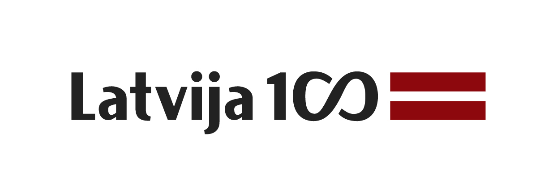
11 September 2021 – 2 January 2022
The main building of the Latvian National Museum of Art / Great Exhibition Hall (-2nd floor)
Jaņa Rozentāla laukums 1, Riga, LV-1010, Latvia

Media tour of exhibition on 9 September 2021 at 11.00
Registration of participants: 10.30–11.00

From 11 September 2021 to 2 January 2022, a Latvian centenary exhibition, The Riga Group of Artists – 100, will be held in the Great Hall of the main building of the Latvian National Museum of Art in Riga (Jaņa Rozentāla laukums 1).

The oeuvre of Aleksandra Beļcova, Jānis Cielavs, Ģederts Eliass, Jāzeps Grosvalds, Jēkabs Kazaks, Eduards Lindbergs, Jānis Liepiņš, Emīls Melderis, Marta Skulme, Oto Skulme, Uga Skulme, Niklāvs Strunke, Romans Suta, Leo Svemps, Erasts Šveics, Valdemārs Tone, Konrāds Ubāns, and Sigismunds Vidbergs reflects a creatively expressive period in the history of Latvian art.

After the gruelling years of the First World War, the young Latvian artists longed to fulfil their creative ambitions and hold exhibitions; accordingly, in 1920, a Riga Group of Artists was established. This first exhibition, which opened at the Riga City Art Museum, presented works by Ģederts Eliass, Jēkabs Kazaks, Eduards Lindbergs, Oto Skulme, Niklāvs Strunke, Romans Suta, Valdemārs Tone, Konrāds Ubāns, Aleksandra Beļcova, and Erasts Šveics. Also the works of Jāzeps Grosvalds, who had died in Paris on 1 February, were included. The Riga Group of Artists declared: “All of the recent years have been really tragic for our art; it seemed that in this sphere, too, we were approaching absolute ruin. Art no longer had any place in our society. In order to fight destitution and surrounding indifference, the artists needed great endurance and self sacrifice. We are no longer satisfied with the simple depiction of real life. Currently, all our strivings are directed towards revealing personality. It is not life, objective, outward life, that we now wish to present through our work, but our own individual character, our spiritual essence.” This first show marked a radical turning point in the quest for means of expression in Latvian painting, initiating a historic process of reassessment of values and thus earning legendary renown.

The exhibition shows the development of the work of the Riga Group of Artists, which is associated with the search for the individual manner of young painters during the First World War, the stylistic manifestations of Cubism and other innovative directions of the 1920s, as well as the transition to a painterly realistic way of expression in the early 1930s. In 1933, art historian Boris Vipper argued that the group “belongs among the most vivid phenomena in Riga art life. The group’s artists were unified by an undeniable commonality of stylistic interests, and nevertheless each of them has retained an independent concept of their own. All of the artworks indicate a serious, profound attitude towards art. Without exaggeration, we may say that the latest word in modern Latvian art is heard most convincingly and most comprehensively at exhibitions by the Riga Group.”

The Riga Group of Artists lost its independent status in 1938, with the founding of the Latvian Chamber of Literature and Art, within which the creative art groups continued their existence only as subdivisions of the Fine Art Section. These, too, were abolished by the Soviet authorities in 1940, and so the Riga Group of Artists ceased to exist as a circle of likeminded individuals. However, the artists continued to create, and the exhibition also discovers the activities of the members of the group during the 1940s – 1960s, both in Latvia and in exile.

In 2020, we celebrated the 125th anniversary of the group’s first chairman, Jēkabs Kazaks, and therefore a separate exhibition in the exhibition consists of his paintings, watercolours and drawings.

The publishing house Neputns has published the catalogue The Riga Group of Artists – 100 in Latvian and English.
Text by Dace Lamberga

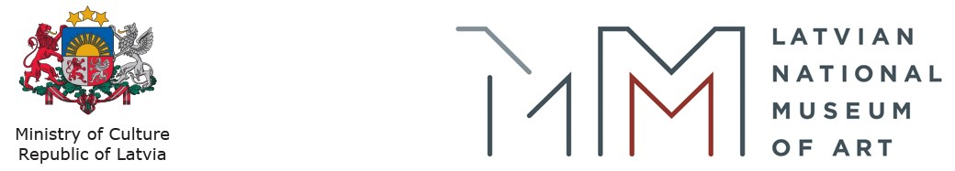

EXHIBITION CURATOR:
Dr. art. Dace Lamberga, Exhibition Curator / Latvian National Museum of Art
Ph: (+371) 67 716103, E: Dace.Lamberga@lnmm.lv

EXHIBITION DESIGNER:
Anna Heinrihsone, artist

PROJECT MANAGER:
Ieva Kalnača, Head of the Project Management Department / Latvian National Museum of Art
Ph: (+371) 67 716123, GSM: (+371) 28 325624, E: Ieva.Kalnaca@lnmm.lv

INTERNET SOURCES:
www.lnmm.lv
FACEBOOK: Latvijas Nacionālais mākslas muzejs
TWITTER: @LNMM_muzejs
INSTAGRAM: @latviannationalmuseumofart
YOUTUBE: Latvian National Museum of Art / LNMMvideos
#lnmm
#MansMuzejs

The main building of the Latvian National Museum of Art / Jaņa Rozentāla laukums 1, Riga, Latvia
OPENING HOURS:
Tuesdays, Wednesdays, Thursdays 10.00–18.00, ticket office 10.00–17.30
Fridays 10.00–20.00, ticket office 10.00–19.30
Saturdays, Sundays 10.00–17.00, ticket office 10.00–16.30
Closed on Mondays

The museum is closed on all public holidays: 1 January, Good Friday, Easter, Midsummer Eve and Day (23–24 June), Christmas (25–26 December), 31 December.

ADMISSION:
Reduced individual admission fee for groups of 10 or more people.
Free admission for the person in charge of the group.
Adults: 3,50 EUR
Schoolchildren, students, seniors: 2,00 EUR
Family ticket (1–2 adults with 1–4 children or family having many children): 5,00–7,00 EUR
Free admission for LNMA Annual ticket holders.

Free entry is also for: pre-school children; orphans or children not under parental care (valid status identification card required); children with a disability up to 18 years, 1st and 2nd group disabled persons (valid status identification card required) and one person accompanying either a child with a disability up to 18 years or a 1st or 2nd group disabled person; pupils of Latvian art schools or professional secondary art schools (valid status identification card required); full-time students of the Art Academy of Latvia (valid status identification card required); students attending institutions of professional secondary education or colleges who are studying or receiving training in visual or applied art, design, cultural history, museology, architecture, restoration as part of their studies or training (on submission of a written application to the museum director at least one day earlier); employees of Latvian museums (valid status identification card required); members of the International Council of Museums (ICOM, valid status membership card required); members of the Latvian Artists’ Union (valid status identification card required); Friend of the LNMA card holders; media representatives who are covering museum events (valid status identification card required); group (no less than 10 persons) leaders – guides or teachers; everyone on the international event Museum Night from 19.00; all visitors to the permanent display on the last Sunday of every month and on International Museum Day – 18th May.

HEALTH AND SAFETY MEASURES AT THE MUSEUM:
- Please do not visit the museum, if you have symptoms of a respiratory infection, or if you must be in self-isolation, home quarantine or strict isolation. The museum has the right to prohibit the entry to the museum to persons with signs of respiratory infection and ask them to leave the museum.
- LNMA museums are open only to individual visitors or members of one household.
- Every museum visitor from the age of 7 must wear a face mask.
- LNMA museums do not provide services to people who do not comply with epidemiological safety requirements, including the use of a face mask.
- During the visit, a distance of 2 meters from other visitors and museum staff must be kept, information in visual instructions and audio announcements, as well as instructions from museum staff must be followed.
- Please use contactless payment and bank cards or register on Mobilly mobile app and conveniently purchase tickets on your phone.
- Each museum has set a maximum number of visitors who can be in the building at the same time, providing at least 25 m² of space per person.
- If possible, a one-way flow of visitors is organized in the museum premises to ensure the distance of 2 meters.
- Please take care of hand disinfection. Museums’ premises and surfaces are regularly cleaned and disinfected.
- Before visiting the LNMA, please check out our latest guidelines regarding prevention, and risk reduction regarding transmission of the current coronavirus in COVID-19 section on museum’s homepage: http://www.lnmm.lv/en/visit/covid_19.

PRESS IMAGES (please request if needed in a larger resolution)
1. Jēkabs Kazaks. Three Women. 1916. Oil on canvas.
Collection of the Latvian National Museum of Art. Photo: Normunds Brasliņš
2. Jēkabs Kazaks. Refugees. 1917. Oil on canvas.
Collection of the Latvian National Museum of Art. Photo: Normunds Brasliņš
3. Romans Suta. Two Women at the Table. Ca. 1917–1918. Oil on canvas.
Collection of the Latvian National Museum of Art. Photo: Normunds Brasliņš
4. Jāzeps Grosvalds. Persian Motif (Mohammedan Mourning Procession). 1919. Oil on canvas.
Collection of the Latvian National Museum of Art. Photo: Normunds Brasliņš
5. Aleksandra Beļcova. Sukub (Decorative panel). 1922. Oil on canvas.
Collection of the Latvian National Museum of Art. Photo: Normunds Brasliņš
6. Uga Skulme. Portrait. Man at the Table. 1923. Oil on canvas.
Collection of the Latvian National Museum of Art. Photo: Normunds Brasliņš
7. Konrāds Ubāns. In the Park. 1923. Oil on canvas.
Collection of the Latvian National Museum of Art. Photo: Normunds Brasliņš
8. Ģederts Eliass. Bathing Women. 1928. Oil on canvas.
Collection of the Latvian National Museum of Art. Photo: Normunds Brasliņš
9. Ģederts Eliass. A Rural Scene. 1931. Oil on canvas.
Collection of the Latvian National Museum of Art. Photo: Normunds Brasliņš
10. Jēkabs Kazaks. Ladies at the Seaside. 1920. Oil on canvas.
Collection of the Latvian National Museum of Art. Photo: Normunds Brasliņš

Press release prepared by: Natalie Suyunshalieva
Head of Press
The Latvian National Museum of Art
Ph: (+371) 67 357527
GSM: (+371) 26 593495
E: pr.service@lnmm.lv
I: www.lnmm.lv
Twitter: www.twitter.com/lnmm_muzejs

