MASS MEDIA RELEASE
Riga, 14 March 2022 [last update: 05.10.2022]

PURVĪTIS  28 May – 16 October 2022  The main building of the Latvian National Museum of Art /  Great Exhibition Hall (-2nd floor)  Jaņa Rozentāla laukums 1, Riga, LV-1010, Latvia  Media tour of exhibition on 27 May 2022 at 11.00  Registration of participants: 10.30–11.00 | 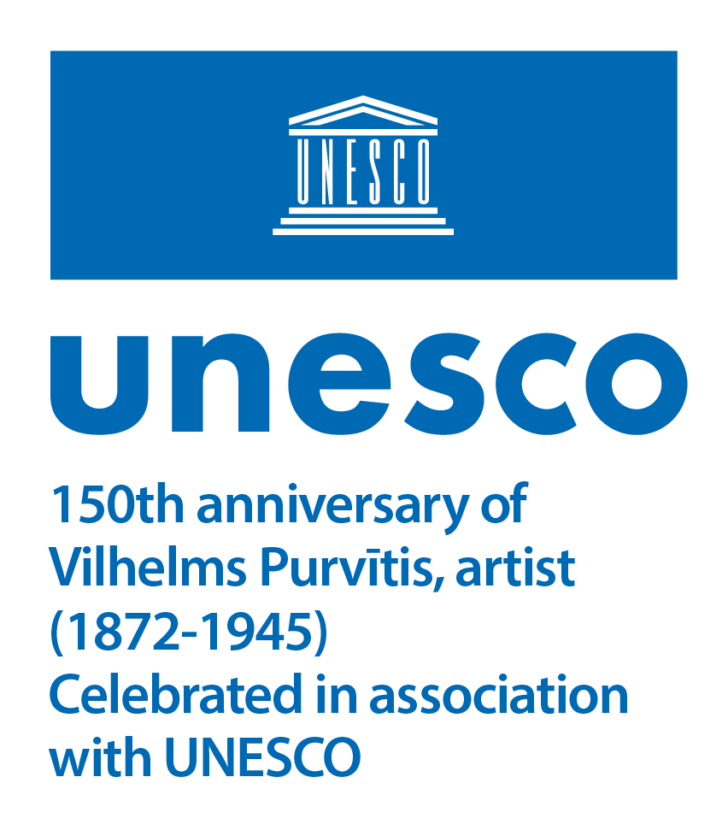

PURVĪTIS, an exhibition dedicated to the 150th anniversary of the outstanding Latvian landscapist Vilhelms Purvītis, is on view in the Great Hall of the main building of the Latvian National Museum of Art in Riga (Jaņa Rozentāla laukums 1) from 28 May to 16 October 2022.

“The deepest essence of a work of art cannot be grasped and exhausted. (...)
The works of the great masters are eternally beautiful and indestructible through the fact
that they have been created with immense power of the spirit. (...)
Eternally unfathomable beauty issues from a true work of art.”
(Vilhelms Purvītis)

The founder and most ambitious moderniser of national landscape painting, Vilhelms Purvītis (1872–1945) is recognised as one of the key figures in Latvian visual art of the first half of the 20th century. At the turn of the century, this accomplished painter of snow and early northern spring was noticed in St. Petersburg, Paris, Munich, Berlin, Vienna and other European art centres. The best-known representative of Baltic modern art was involved as equal in the latest transformations of the genre of landscape, achieving success abroad, authority in the artistic life of Riga and from then on a consistently high standing in the Latvian art world.

In Latvian art history and public perception, the name of this European Latvian classic has become one of the symbols of national identity. As poetic archetypes, “Purvītis-style” images, motifs and moods retain their presence in our sense and understanding of the landscapes that surround us. The painter’s vision of his native northern nature, as well as his classically composed ideal Latvian landscapes in changing seasons, are considered to be the canon of national landscape.

Purvītis deserves particular recognition as an implementer of the idea of higher artistic education and one of the architects of the cultural policy in the independent Latvian state, as the first rector of the Art Academy of Latvia and head of the Landscape Painting Master Class, and at the same time – as director of the prestigious Riga City Art Museum (now Latvian National Museum of Art), creator of the national art collection and organiser of representative international exhibitions.

This anniversary retrospective dedicated to the landscapist encompasses a selection of works from different periods of his career from the collection of the Latvian National Museum of Art – the largest surviving group of the artist’s paintings and graphic art, which is expanded with exhibits from the collections of Liepāja and Tukums museums and several private collections – including from the Belēvičs family, Andris Kļaviņš, the Zuzāns and others.

Alternating between more traditional painterly expression and one modernised by a multitude of influences, the artistic self-development and stylistic fluctuations of “early” and “late” Purvītis are revealed in the exhibition in the spectrum from plein-air studies and neo-romantic mood landscapes to broad panoramas marked by classical tradition and the composition of a majestic national landscape canon.

With the decision of the 41st session of the UNESCO General Conference adopted in November 2021, Vilhelms Purvītis’ 150th anniversary has been included in the list of celebrations with which UNESCO will be associated in 2022. Promoting international understanding of the diversity and achievements of world culture, UNESCO is marking anniversaries of events that are significant to member countries as well as highlighting personalities who, through their work, have made a significant contribution to the development of education, science and culture.

During the exhibition, the Latvian National Museum of Art offers the unprecedented opportunity to climb 4-metre-high scaffolding to have a closer look at one of Purvītis’ wall landscapes decorating the 3rd floor vestibule – Koknese Castle Ruins, created in 1907. The museum’s three lunette compositions are the artist’s only contribution to monumental decorative painting.

As a satellite to the exhibition, taking the place of Vilhelms Purvītis’ paintings in the hall of the permanent exhibition of Latvian art at the turn of the 19th and 20th centuries, is a group of Kristaps Kalns’ photographs titled Prototype, which thematically merge the permanence of the classics of painting with a documentation of today’s reality. Capturing the Latvian landscape in the changing seasons, the artist investigates from a documentary observer’s position the images, classical motifs and principles of composition that we know from Purvītis’ paintings.

An audio guide for the exhibition tells about ten Vilhelms Purvītis’ works in Latvian and English. Its use inside the exhibition requires a personal mobile phone and headphones, but these stories are also available for listening from any place with an access to internet. The audio guide is available free of charge in the LNMA mobile application and on SoundCloud.
Text by Aija Brasliņa

Exhibition supported by:
The State Culture Capital Foundation, Riga City Council, GroGlass Ltd., Attēls R Ltd., JSC Riga Wood Baltic, Latvian State Archive of Audiovisual Documents of the National Archives of Latvia

Exhibition curator:
Dr. art. Aija Brasliņa, Head of the Collections and Scientific Research Department and Curator of the Painting Collection (18th – 1st Half of the 20th Century) / Latvian National Museum of Art
Ph: (+371) 67 716 118, E: Aija.Braslina@lnmm.lv

Scientific consultant:
Dr. art. Kristiāna Ābele, senior researcher at the Institute of Art History / Art Academy of Latvia

Project manager:
Ieva Kalnača, Head of the Project Management Department / Latvian National Museum of Art
Ph: (+371) 67 716 123, GSM: (+371) 28 325 624, E: Ieva.Kalnaca@lnmm.lv

Exhibition design:
Sandra Krastiņa

Graphic design and video:
Mārtiņš Ratniks

INTERNET SOURCES:
www.lnmm.lv
FACEBOOK: Latvijas Nacionālais mākslas muzejs
TWITTER: @LNMM_muzejs
INSTAGRAM: @makslasmuzejs
YOUTUBE: MĀKSLAS MUZEJI / LNMMvideos
The PURVĪTIS exhibition promo video: https://youtu.be/q6DW30FxlxA; https://youtu.be/OTdQ6DGnArU
#lnmm
#MansMuzejs

The main building of the Latvian National Museum of Art / Jaņa Rozentāla laukums 1, Riga, Latvia
OPENING HOURS:
Tuesdays, Wednesdays, Thursdays 10.00–18.00, ticket office 10.00–17.30
Fridays 10.00–20.00, ticket office 10.00–19.30
Saturdays, Sundays 10.00–17.00, ticket office 10.00–16.30
Closed on Mondays

The museum is closed on all public holidays: 1 January, Good Friday, Easter, Midsummer Eve and Day (23–24 June), Christmas (25–26 December), 31 December.

ADMISSION:
Reduced individual admission fee for groups of 10 or more people.
Free admission for the person in charge of the group.
During the exhibition we offer the Combined Ticket which allows you to visit the entire museum.
Adults: 6,00 EUR
Students, seniors: 3,00 EUR
Schoolchildren: 2,00 EUR
Viewing of the exhibition and satellite expositions on 29 May, 26 June, 31 July, 28 August, 25 September:
Adults: 3,50 EUR
Schoolchildren, students, seniors: 2,00 EUR
Family ticket (1–2 adults with 1–4 children or family having many children): 5,00–7,00 EUR
Free admission for LNMA Annual ticket holders.

Free entry is also for: pre-school children; orphans or children not under parental care (valid status identification card required); children with a disability up to 18 years, 1st and 2nd group disabled persons (valid status identification card required) and one person accompanying either a child with a disability up to 18 years or a 1st or 2nd group disabled person; pupils of Latvian art schools or professional secondary art schools (valid status identification card required); full-time students of the Art Academy of Latvia (valid status identification card required); students attending institutions of professional secondary education or colleges who are studying or receiving training in visual or applied art, design, cultural history, museology, architecture, restoration as part of their studies or training (on submission of a written application to the museum director at least one day earlier); employees of Latvian museums (valid status identification card required); members of the International Council of Museums (ICOM, valid status membership card required); members of the Latvian Artists’ Union (valid status identification card required); Friend of the LNMA card holders; media representatives who are covering museum events (valid status identification card required); group (no less than 10 persons) leaders – guides or teachers; Ukrainian citizens by presenting an identity document or other document proving Ukrainian citizenship; everyone on the international event Museum Night from 19.00; all visitors to the permanent display on the last Sunday of every month and on International Museum Day – 18th May.

HEALTH AND SAFETY MEASURES AT THE MUSEUM:
- Please do not visit the museum, if you have symptoms of a respiratory infection, or if you must be in self-isolation, home quarantine or strict isolation. The museum has the right to prohibit the entry to the museum to persons with signs of respiratory infection and ask them to leave the museum.
- During the visit, a distance of 2 meters from other visitors and museum staff must be kept. If possible, a one-way flow of visitors is organized in the museum premises to ensure the distance of 2 meters.
- Please use contactless payment and bank cards or register on Mobilly mobile app and conveniently purchase tickets on your phone.
- Please take care of hand disinfection. Museums’ premises and surfaces are regularly cleaned and disinfected.

PRESS IMAGES (please request if needed in a larger resolution)
1. Visual identity of the PURVĪTIS exhibition. 2022. Detail of a still from the report about Vilhelms Purvītis’ last personal exhibition at the Riga City Art Museum in the newsreel Ausland Woche (No. 552, 1942, Studio UFA, Latvian State Archive of Audiovisual Documents of the National Archives of Latvia)
2. Vilhelms Purvītis. Northern Night. 1900. Oil on canvas.
Collection of the Latvian National Museum of Art. Photo: Normunds Brasliņš
3. Vilhelms Purvītis. March Evening. No later than 1901. Oil on canvas.
Collection of the Latvian National Museum of Art. Photo: Normunds Brasliņš
4. Vilhelms Purvītis. Winter. Ca 1910. Oil on cardboard.
Collection of the Latvian National Museum of Art. Photo: Normunds Brasliņš
5. Vilhelms Purvītis. Autumn Sun (Autumn Gold). No later than 1910. Oil on canvas.
Collection of the Latvian National Museum of Art. Photo: Normunds Brasliņš
6. Vilhelms Purvītis. Spring Waters (Maestoso). No later than 1911. Oil on canvas.
Collection of the Latvian National Museum of Art. Photo: Normunds Brasliņš
7. Vilhelms Purvītis. In Ķeizardārzs (In Viesturdārzs). Ca 1914. Oil on cardboard.
Collection of the Latvian National Museum of Art. Photo: Normunds Brasliņš
8. Vilhelms Purvītis. Summer Landscape. First half of the 1920s. Oil on cardboard.
Collection of the Latvian National Museum of Art. Photo: Normunds Brasliņš
9. Vilhelms Purvītis. In Spring (Springtime). Ca 1933–1934. Oil on cardboard.
Collection of the Latvian National Museum of Art. Photo: Normunds Brasliņš
10. Vilhelms Purvītis. Ca 1898. Photographer unknown. Collection of the Literature and Music Museum. Publicity photo
11. Vilhelms Purvītis. Ca 1913 (photo postcard ca 1920). Photo: Mārtiņš Lapiņš.
Collection of the Riga History and Navigation Museum
12. Vilhelms Purvītis. 1925. Photo: Vilis Rīdzenieks. LNMA photo archive
13. Vilhelms Purvītis. 1938. Photo: Roberts Johansons. Collection of the Riga History and Navigation Museum
14. Vilhelms Purvītis in plein-air at Mārciena. 1943. Photo: Jānis Maršāns.
Collection of the Art Academy of Latvia Information Centre
15. UNESCO logotype, dedicated to the artist Vilhelms Purvītis 150th anniversary. 2022

Press release prepared by: Natalie Suyunshalieva
Head of Press
The Latvian National Museum of Art
Ph: (+371) 67 357 527
GSM: (+371) 26 593 495
E: pr.service@lnmm.lv
I: www.lnmm.lv
Twitter: www.twitter.com/lnmm_muzejs

