MASS MEDIA RELEASE
Riga, 24 September 2025

Traces and Roots. Anatolia in Contemporary Art of Turkey

4 October 2025 – 18 January 2026
Art Museum RIGA BOURSE / Great Exhibition Hall
Doma laukums 6, Riga

Media event on 3 October 2025 at 10.00
Registration of participants: 09.30–10.00

The exhibition Traces and Roots. Anatolia in Contemporary Art of Turkey is taking place at the Art Museum RIGA BOURSE in Riga (Doma laukums 6) from 4 October 2025 to 18 January 2026.

Anatolia, the crossroads of Europe and Asia, has been a meeting point for different cultures since the dawn of civilization, where layer upon layer has formed the values of modern Turkey. The exhibition Traces and Roots, created in cooperation with the Embassy of the Republic of Türkiye in Latvia, brings together twelve prominent artists from Turkey whose works reveal the story of the encounter between Anatolia’s thousands of years of cultural heritage and contemporary art.

Inspired by the rich history and culture of their homeland both intellectually and visually, these artists combine traces of Anatolia’s past, traditional motifs and symbols with contemporary artistic language and unique forms of expression. The exhibition thus takes the viewer on an impressive journey from the past to the present.

About the exhibition artists
Aydin Ayan’s paintings combine history, mythology and social events. He uses Anatolian legends, folk tales and cultural motifs, interpreting them in detailed narratives that also incorporate symbolic elements characteristic of this ancient region. Ayan’s works contain both traces of the past and a critical view of today’s world.

Habip Aydoğdu’s paintings are saturated with powerful colour energy and dynamism. The intense use of red tones in his abstract compositions symbolizes the artist’s belonging and passion for his native Anatolia. It is a history of struggles and cultural clashes, the echoes of which can still be felt today.

Resul Aytemur mostly paints urban scenes – street markets, transport stops, squares, and parks. These are usually multi-figure compositions with a rich colour palette, conveying the atmosphere of the city: human relationships, joy, collective tension or a spirit of protest.

Beril Anilanmert creates dynamic, expressive ceramic sculptures and ceramic two-dimensional paintings. She incorporates metal, textiles and glass into traditional ceramic materials, highlighting the aesthetics of incompleteness. Artist’s contemporary works draw thematic inspiration from mythology and social life.

At first glance, Zehra Çobanli’s ceramic works often seem to be associated with intimate, typically feminine elements and activities – shoes, tea / coffee rituals, feeding poultry. But these everyday motifs form a narrative around themes such as status, migration and vulnerability. Çobanli combines the Anatolian ceramic heritage with conceptual art, reinterpreting historical motifs in a contemporary context.

Devrim Erbil (Selen Karaibrahim) combines abstraction and figurative elements in his painting. Urban landscapes occupy a particularly important place in author’s artistic narrative – rhythmically structured compositions, captured as if from a bird’s eye view, with motifs from Anatolian architecture and nature. Here, the linear aesthetics of traditional Turkish art, which resonates with the art of calligraphy, merges with a deliberately chosen monochrome or limited colour palette.

Yalçin Gökçebağ paints idyllic scenes of rural life of Anatolia, showing the mutual rhythms of man and nature, peaceful everyday life, where work alternates with rest. In his compositions, the perspective from above gives the depicted flow of life a timelessness and a slightly nostalgic atmosphere.

Fevzi Karakoç is drawn to mysticism, the human emotional world and symbolic images (birds, horses, trees), which he uses to explore existential themes. Anatolian nature, folklore, Eastern philosophy, and Turkish poetry are Karakoç’s sources of inspiration. With lush brushstrokes rhythmically painted figures interact with the expressive backgrounds, giving the artworks additional depth.

Alaybey Karoğlu often prefers simplified, abstract forms and factures in his works, reminiscent of moody landscapes, sometimes complemented by human figures from the past. His paintings are characterized by expressive colour fields and broad brushstrokes. Karoğlu combines symbolism and cultural motifs that are important to Anatolia with personal iconography, for example, using images such as Mavi Türkü (Blue Folk Song) to make the narrative multi-layered in terms of content.

Temür Köran is a contemporary Turkish painter known for his expressive visual language, which combines abstract and figurative elements with rich colours and dynamic compositions. Author’s works often reflect themes of memory, identity and the human emotional state.

Hasan Pekmezci vividly represents the tradition of figurative painting in Turkey, focusing on Turkish culture and human emotions. His works combine figurative and expressionist elements with a strong narrative and sense of identity. Inspired by both everyday life and folk art, Pekmezci reinterprets the visual heritage of Anatolia.

Şükran Pekmezci emphasizes the role of women in Anatolian culture. The depiction of ritualized events in everyday life creates a link between the past and the present, also recalling ancient craft skills: ceramics, weaving and miniature painting. Artist’s painting themes are rooted in the events of rural village life: weddings, folk festivals, the arrival of the first snow, and reflect the unmediated authenticity of Anatolian traditions.

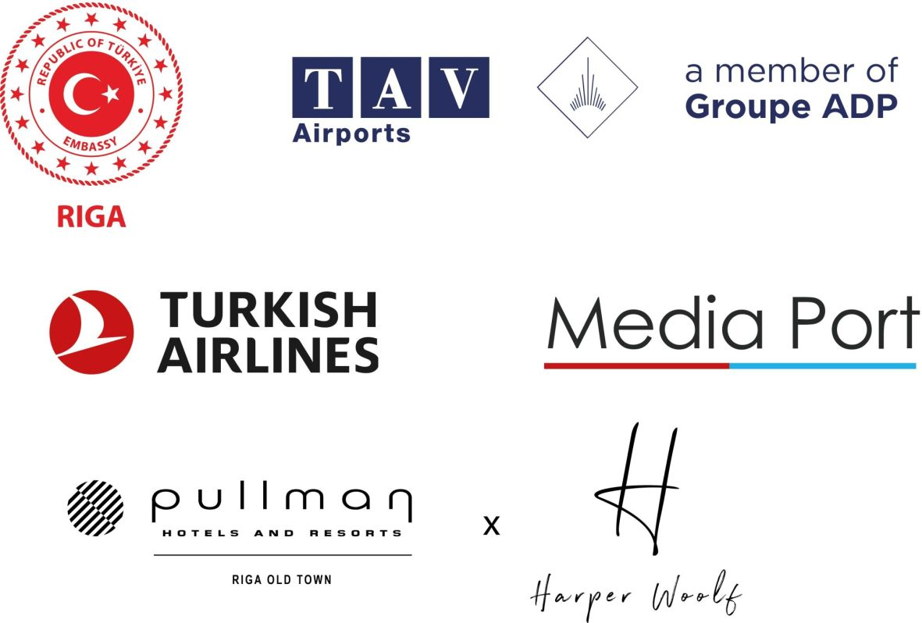

Exhibition curator:
Siret Uyanik / Turkey

Exhibition project consultant:
Prof. Dr. Aydin Ayan / Turkey

Project manager:
Vita Birzaka, Deputy Head of the Foreign Art Department / Art Museum RIGA BOURSE /
Latvian National Museum of Art
Ph: (+371) 67 357 535, E: Vita.Birzaka@lnmm.gov.lv

Exhibition scenography:
Şeyma Kont / Turkey

Graphic design:
İrem Doğan / Turkey
Kristīne Jansone / Art Museum RIGA BOURSE / Latvian National Museum of Art

Educational programme:
Anna Roze, Nikola Rundāne, Vita Ozoliņa / Art Museum RIGA BOURSE / Latvian National Museum of Art

Exhibition communication:
Katrīna Ģelze / Communication Specialist / Art Museum RIGA BOURSE / Latvian National Museum of Art
Ph: (+371) 67 357 534, E: Katrina.Gelze@lnmm.gov.lv

INTERNET SOURCES:
https://lnmm.gov.lv
FACEBOOK: Mākslas muzejs RĪGAS BIRŽA
X: @MuzejsRigaBirza
INSTAGRAM: @makslasmuzejsrigasbirza
#lnmm
#RigasBirza
#MansMuzejs

Art Museum RIGA BOURSE / Doma laukums 6, Riga, Latvia
OPENING HOURS:
Tuesdays, Wednesdays, Thursdays, Saturdays, Sundays 10.00–18.00, ticket office 10.00–17.30
Fridays 10.00–20.00, ticket office 10.00–19.30
Closed on Mondays

The museum is closed on all public holidays: 1 January, Good Friday, Easter, Midsummer Eve and Day (23–24 June), Christmas (25–26 December), 31 December.

ADMISSION:
Adults: 8,00 EUR
Pupils, students, seniors: 4,00 EUR
Family ticket (1–2 adults with 1–4 children or family having many children): 8,00–12,00 EUR
Free admission for LNMA Annual ticket holders.
Reduced individual admission fee for groups of 10 or more people.
Free admission for the person in charge of the group.

Free entry is also for (valid status identification card required): pre-school children; orphans or children not under parental care; day-care centre, crisis centre and special education pupils; children placed in a social rehabilitation centre and accompanying persons (one teacher or one person per 10 children or pupils); children under 18 years with a disability; persons with a disability 1st and 2nd group; one person accompanying either a child under 18 years with a disability or a person with disability of 1st group; a sign language interpreter accompanying a person with disability of 1st, 2nd or 3rd group; pupils of Latvian art schools or professional secondary art schools; full- and part-time students of the Art Academy of Latvia; students attending institutions of professional secondary education or colleges who are studying or receiving training in visual or applied art, design, cultural history, museology, cultural heritage, architecture, restoration as part of their studies or training; members of the Latvian Artists’ Union; employees of Latvian museums; members of the International Council of Museums (ICOM); members of the International Council on Monuments and Sites (ICOMOS); Friend of the LNMA card holders; participants of the museum programmes Volunteer Programme and Youth Club; media representatives who are covering museum events; group leaders or teachers (minimum 10 persons); Ukrainian citizens; visitors to events organised by the museum during the annual international campaign European Night of Museums and the contemporary culture forum White Night; all visitors to the permanent exhibition on the last Sunday of every month and on International Museum Day – 18th May.

PRESS IMAGES (please request if needed in a larger resolution)
- Visual identity of the exhibition Traces and Roots. Anatolia in Contemporary Art of Turkey. 2025. Design: İrem Doğan, Kristīne Jansone. Publicity photo
2. Zehra Çobanli. A Cup of Coffee Is Remembered for Forty Years. 1998. Stoneware, brown slip. Publicity photo
3. Aydin Ayan. Loneliness Cannot Be Shared. 2012. Oil on canvas. Publicity photo
4. Resul Aytemur. A Cheese Seller in Beşiktaş Bazaar. 2013. Oil on canvas. Publicity photo
5. Hasan Pekmezci. Time. 2013. Oil on canvas. Publicity photo
6. Devrim Erbil (Selen Karaibrahim). Rhythmic Abstraction No. 6. 2013. Oil on canvas. Publicity photo
7. Beril Anilanmert. Altar. 2014. Faience, slip cast. Publicity photo
8. Yalçin Gökçebağ. Harvest on Noon. 2016. Oil on canvas. Publicity photo
9. Habip Aydoğdu. The Path to Paradise. 2016. Acrylic on canvas. Publicity photo
10. Şükran Pekmezci. Winter. 2018. Oil on canvas. Publicity photo
- Fevzi Karakoç. Phase of Transformation. 2023. Acrylic on canvas. Publicity photo
12. Alaybey Karoğlu. Variation on Site Area. 2025. Acrylic on canvas. Publicity photo
13. Temür Köran. Untitled. 2025. Oil on canvas. Publicity photo

Press release prepared by: Natalie Suyunshalieva
Head of Press
The Latvian National Museum of Art
Ph: (+371) 67 357 527
GSM: (+371) 26 593 495
E: pr.service@lnmm.gov.lv
I: https://lnmm.gov.lv
X: www.x.com/LNMM_muzejs

